English
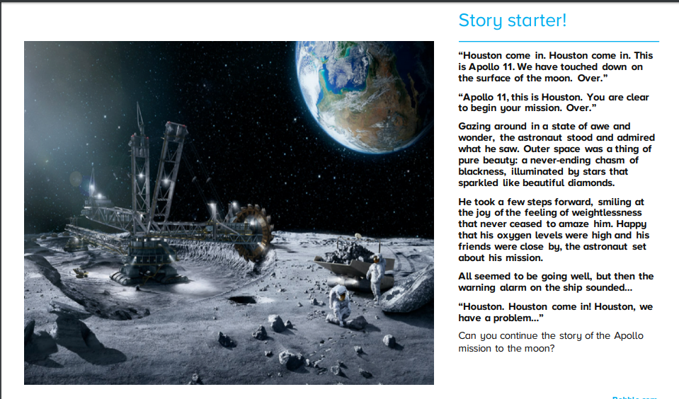
https://www.bbc.co.uk/programmes/p012yxch
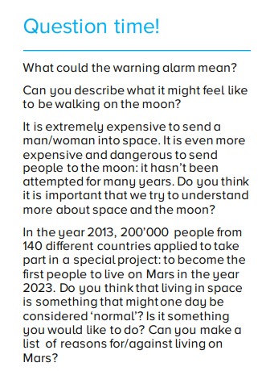
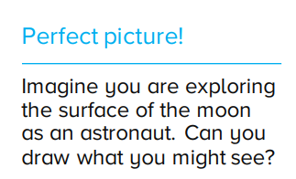

Other ideas
Biography of an astroanut- choose one of the three astronauts who went in the Apollo 11 rocket. Introduce the person in the first paragraph adn explain why they are famous. Then write about key events that have happened in the persons life. Your final paragraph needs to explain why and how your astronaut will be remembered.

Newspaper report of first moon landing- remember to include a headline, the name of the newspaper, to write in columns and include a quote. https://www.bbc.co.uk/bitesize/topics/z2yycdm/articles/z2gk9qt

Diary of Neil Armstrong – write in the perspective of Neil Armstrong. Start with climbing into the Apollo 11, how are you feeling? What do you have to do? What are you wearing? You have just taken off, what is happening? You finally get out into space, what can you see? It is time to land on the moon, the first time anyone in history has done this. Describe the moon. Can you include his famous quote!

